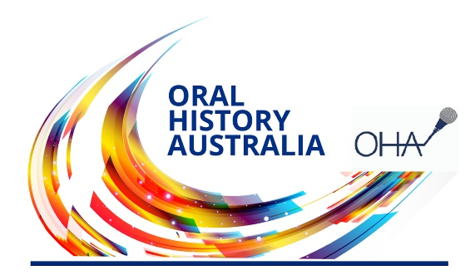
INVOICE

Oral History Australia SA/NT Inc
PO Box 3113
Unley SA 5061 Australia
www.oralhistoryaustraliasant.org.au

ABN: 80 863758027

Membership of the OHA includes a subscription to the Journal of the OHA published annually. There are Associations in all Australian States. Northern Territory members are attached to the SA Association and ACT members to NSW. State Associations hold regular meetings, run workshops, and publish regular newsletters, and also provide a friendly and informative forum for those interested in oral history from any perspective.

Membership fees (please circle as appropriate)

Individual: $40

Institution: $65

Student/Pensioner/Unemployed: $30

Household: $55

I wish to join OHA SA/NT:

For period 1July 2022 to 30 June 2023
I wish to renew my membership:

NAME: ___________________________________________________________________

ADDRESS: ________________________________________________________________

_________________________________________ Postcode: _______________________

PENSION/STUDENT NO.: ____________________________________________________

TELEPHONE:__________________________ EMAIL: ________________________________

(For new members only) I GIVE PERMISSION FOR MY NAME TO BE PUBLISHED IN THE MEMBER MAGAZINE ‘WORD OF MOUTH’ YES NO

ORAL HISTORY INTEREST(S): ______________________________________________________________

FOR FUTURE PLANNING PURPOSES, IS THERE A SPECIFIC ORAL HISTORY WORKSHOP THAT INTERESTS YOU? EG VIDEO ORAL HISTORY; COMMUNITY HISTORY; DIGITAL STORYTELLING

PAYMENT METHOD (please tick one):

Cheque ☐ Money order ☐ Cash (in person only) ☐

Direct credit (as below) ☐

Direct Credit banking details: Other Payments please forward to:
Bank: National Australia Bank (NAB) The Treasurer
BSB: 085 436 PO Box 3113
Account No: 12931 2048 Unley SA 5061

Please make certain you indicate who the payment is from and forward a copy of the form by mail (as above) or email to contact@oralhistoryaustraliasant.org.au for verification.

