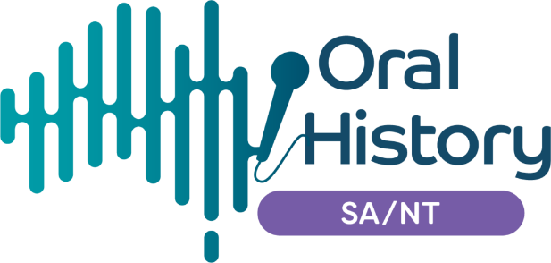
INVOICE

Oral History Australia SA/NT Inc
PO Box 163
Barmera SA 5345 Australia
www.oralhistoryaustraliasant.org.au

ABN: 80 863758027

Membership of the OHA includes a subscription to the Journal of the OHA published annually. There are Associations in all Australian States. Northern Territory members are attached to the SA Association and ACT members to NSW. State Associations hold regular meetings, run workshops, publish regular newsletters, and provide a friendly and informative forum for those interested in oral history from any perspective.

Membership fees for period 1 July 2023 to 30 June 2024
(Please select one)

☐ Individual: $40
☐ Student/Pensioner/Unemployed: $30
☐ Institution $65

☐ I wish to join OHA SA/NT

☐ I wish to renew my membership.

Name: ____________________________________________________________________________________________________

Address: ___________________________________________________________________________________________________

_______________________________________________________________Postcode: _____________________________

Pension/Student number: ___________________________________________________________________________

Mobile: __________________________________ Email: _________________________________________________________

ORAL HISTORY INTEREST(S): ____________________________________________________________________________

FOR FUTURE PLANNING PURPOSES, IS THERE A SPECIFIC ORAL HISTORY WORKSHOP THAT INTERESTS YOU? EG VIDEO ORAL HISTORY; COMMUNITY HISTORY; DIGITAL STORYTELLING?

PAYMENT METHOD (please tick one):

☐ Direct Credit ☐ Cheque

Direct Credit banking details: Please forward with this form to:
Bank: National Australia Bank (NAB) The Treasurer
BSB: 085 436 PO Box 163
Account No: 12931 2048 Barmera SA 5345

Add your SURNAME as a REFERENCE.

Email this form to contact@oralhistoryaustraliasant.org.au for verification.

